Format pour les articles soumis à SFE 2016
Paper Format for the SFE 2016

A. B. Surname¹, C. D. Surname²
¹Department of Electrical Engineering, University of Orthanc, Isengard
²Department of Power Engineering, University of Hobbiton, Shire

Abstract—This is the final format of the paper to be printed in the International Journal of Plasma Environmental Science and Technology. Page limit of the regular papers is up to 6 pages, and research note is 1 page. After the review is completed, the authors must submit the final manuscript using this format.
A4 page size of 210 mm × 297 mm (8.27" × 11.69")
Page margin: top and bottom 25 mm, right and left 20 mm
Times new roman,

Keywords—Fonts, formatting, margins

I. INTRODUCTION

To write your conference paper use this template

II. METHODOLOGY

- Type sizes and typefaces
Corresponding author: name
e-mail address:

Use 14 point bold, capital letters for the title, 12 point Times New Roman (normal) characters for author information and for the main text.

- Format:

In formatting your page, set top and bottom margin to 25 mm. Left and right margins should be 20 mm. Use a two-column format.
Left and right-justify your columns. Use tables and figures to adjust column length. Use automatic hyphenation and check spelling. All figures, tables, and equations must be included in-line with the text. Do not use links to external files.

III. RESULTS

A. Figures and Tables

For printed journal, colored manuscript is printed with B&W, but in the web version colored graphs and tables can be used.

Table I
Type sized for camera-ready papers

Type Size (pts) | Appearance
Type Size (pts) | Regular |  |  | Bold | Italic
10 | Table captions
 | Section titles, tables, table names , table superscripts, figure captions, text subscripts and superscripts,  footnotes  Abstract |  |  |  | Sub-heading
9 | references,
12 | Authors’ name, affliations, main text, equations,
14 |  |  |  | Paper-title

Large figures and tables may span across both columns. Figure captions should be below the figures; table names and table captions should be above the tables. Use the abbreviation “Fig.” even at the beginning of a sentence.
Figure axis labels are often a source of confusion. Try to use words rather than symbols. As an example, write the quantity “Magnetization,” or “Magnetization M,” not just “M.” Put units in parentheses. Do not label axes only with units. As in Fig. 1, for example, write “Magnetization (A/m)” or “Magnetization (Am⁻¹),” not just “A/m.” Do not label axes with a ratio of quantities and units. For example, write “Temperature (K),” not “Temperature/K.”

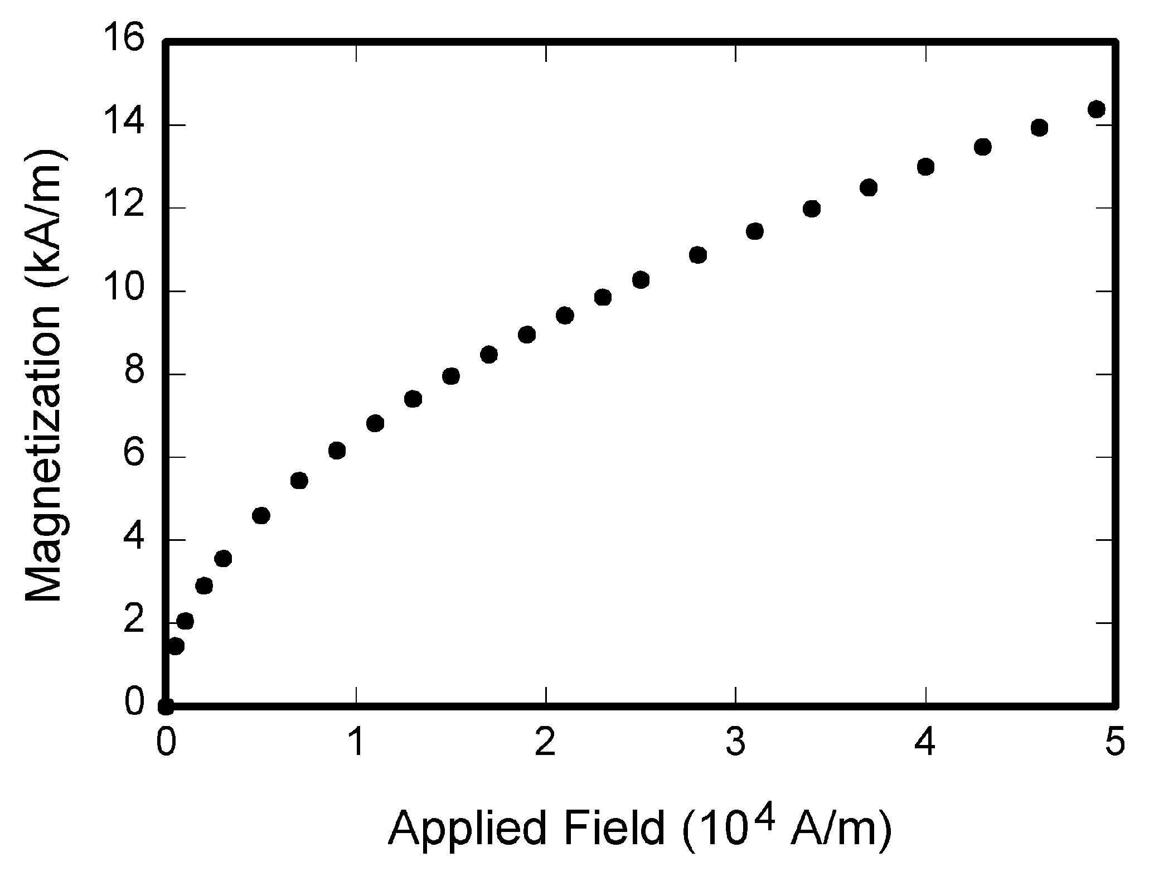

Fig. 1. Magnetization vs. applied field.

Note how the caption is centered in the column.

Multipliers can be especially confusing. Write “Magnetization (kA/m)” or “Magnetization (10³ A/m).” Do not write “Magnetization (A/m) × 1000” because the reader would not know whether the top axis label in Fig. 1 meant 16000 A/m or 0.016 A/m. Figure labels should be legible, approximately 10-point type.

B. References

Number citations consecutively in square brackets [1]. The sentence punctuation follows the bracket [2]. Refer simply to the reference number, as in [3]. Do not use “Ref. [3]” or “reference [3]” except at the beginning of a sentence:
“Reference [3] shows ... .”
Please note that the references at the end of this document are in the preferred referencing style. Give all authors’ names; do not use “et al.” unless there are six authors or more. Use a space after authors' initials. Papers that have not been published, even if they have been submitted for publication, should be cited as “unpublished” [4]. Papers that have been accepted for publication should be cited as “in press” [5].
Capitalize only the first word in a paper title, except for proper nouns and element symbols. For papers published in translation journals, please give the English citation first, followed by the original foreign-language citation [6].

C. Abbreviations and Acronyms

Define abbreviations and acronyms the first time they are used in the text, even after they have already been defined in the abstract. Abbreviations such as IEEE, SI, MKS, CGS, ac, dc, and rms do not have to be defined. Abbreviations that incorporate periods should not have spaces: write “C.N.R.S.,” not “C. N. R. S.” Do not use abbreviations in the title unless they are unavoidable (for example, “IEEE” in the title of this article).

D. Equations

Number equations consecutively with equation numbers in parentheses flush with the right margin, as in (1). To make your equations more compact, you may use the solidus ( / ), the exp function, or appropriate exponents. Use a long dash rather than a hyphen for a minus sign. Use parentheses to avoid ambiguities in denominators. Punctuate equations with commas or periods when they are part of a sentence, as in

A + B = C. (1)

Be sure that the symbols in your equation have been defined before the equation appears or immediately following. Italicize variables (T might refer to temperature, but T is the unit tesla). Refer to “(1),” not “Eq. (1)” or “equation (1),” except at the beginning of a sentence: “Equation (1) is ... .”

E. Other Recommendations

The Roman numerals used to number the section headings are optional. If you do use them, number INTRODUCTION, but not ACKNOWLEDGMENT and REFERENCES, and begin Subheadings with letters. Use one space after periods and colons. Hyphenate complex modifiers: “zero-field-cooled magnetization.” Avoid dangling participles, such as, “Using (1), the potential was calculated.” Write instead, “The potential was calculated using (1),” or “Using (1), we calculated the potential.”
Use a zero before decimal points: “0.25,” not “.25.” Use “cm³,” not “cc.” Indicate sample dimensions as “0.1 cm × 0.2 cm,” not “0.1 × 0.2 cm².” The abbreviation for “seconds” is “s,” not “sec.” Do not mix complete spellings and abbreviations of units: use “Wb/m²” or “webers per square meter,” not “webers/m².” When expressing a range of values, write “7 to 9” or “7-9,” not “7~9.” Spell units when they appear in text: “…a few henries,” not “…a few H.” If your native language is not English, try to get a native English-speaking colleague to proofread your paper. Number each page at top, right corner: “1 of 3,” “2 of 3,” etc.

IV. DISCUSSION

Use either SI (MKS) or CGS as primary units. (SI units are strongly encouraged.) English units may be used as secondary units (in parentheses). This applies to papers in data storage. For example, write “15 Gb/cm² (100 Gb/in²).” An exception is when English units are used as identifiers in trade, such as “3.5-inch disk drive.”
Avoid combining SI and CGS units, such as current in amperes and magnetic field in oersteds. This often leads to confusion because equations do not balance dimensionally. If you must use mixed units, clearly state the units for each quantity that you use in an equation.

V. CONCLUSION

Finally, you are responsible for language as editors will not check it. Do a spell and grammar check. This is available in Word. If English is not your native language, get a professional proof-reader to help if possible.
The word “data” is plural, not singular. The subscript for the permeability of vacuum µ₀ is zero, not a lowercase letter “o.” In American English, periods and commas are within quotation marks, like “this period.” A parenthetical statement at the end of a sentence is punctuated outside of the closing parenthesis (like this). (A parenthetical sentence is punctuated within the parentheses.) A graph within a graph is an “inset,” not an “insert.” The word “alternatively” is preferred to the word “alternately” (unless you really mean something that alternates). Use the word “whereas” instead of “while” (unless you are referring to simultaneous events). Do not use the word “essentially” to mean “approximately” or “effectively.” Do not use the word “issue” as a euphemism for “problem.”
Be aware of the different meanings of the homophones “affect” (usually a verb) and “effect” (usually a noun), “complement” and “compliment,” “discreet” and “discrete,” “principal” (e.g., “principal investigator”) and “principle” (e.g., “principle of measurement”). Do not confuse “imply” and “infer.”
Prefixes such as “non,” “sub,” “micro,” “multi,” and “ultra” are not independent words; they should be joined to the words they modify, usually without a hyphen. There is no period after the “et” in the Latin abbreviation “et al.” (it is also italicized). The abbreviation “i.e.,” means “that is,” and the abbreviation “e.g.,” means “for example” (these abbreviations are not italicized).

ACKNOWLEDGMENT

The preferred spelling of the word “acknowledgment” in American English is without an “e” after the “g.” Use the singular heading even if you have many acknowledgments. Avoid expressions such as “One of us (J.Q.A.) would like to thank ... .” Instead, write “J. Q. Author thanks ... .” Sponsor and financial support acknowledgments are placed in the unnumbered footnote on the first page.

REFERENCES
- D. J. Beebe, “Signal conversion (Book style with paper title and editor),” in Biomedical Digital Signal Processing, W. J. Tompkins, Ed. Englewood Cliffs, NJ: Prentice-Hall, 1993, ch. 3, pp. 61–74M. Akay
- M. Akay, Time Frequency and Wavelets in Biomedical Signal Processing (Book style). Piscataway, NJ: IEEE Press, 1998, pp. 123–135
- G. B. Gentili, V. Tesi, M. Linari, and M. Marsili, “A versatile microwave plethysmograph for the monitoring of physiological parameters (Periodical style),” IEEE Trans. Biomed. Eng., vol. 49, no. 10, pp. 1204–1210, Oct. 2002.
- V. Medina, R. Valdes, J. Azpiroz, and E. Sacristan, “Title of paper if known,” unpublished.
- E. H. Miller, “A note on reflector arrays (Periodical style Accepted for publication),” IEEE Trans. Antennas Propagat., in press.
- T. Menendez, S. Achenbach, W. Moshage, M. Flug, E. Beinder, A. Kollert, A. Bittel, and K. Bachmann, “Prenatal recording of fetal heart action with magnetocardiography” (in German), Zeitschrift für Kardiologie, vol. 87, no. 2, pp. 111–8, 1998.
- J. E. Monzon, “The cultural approach to telemedicine in Latin American homes (Published Conference Proceedings style),” in Proc. 3rd Conf. Information Technology Applications in Biomedicine, ITAB´00, Arlington, VA, pp. 50–53.
- F. A. Saunders, “Electrotactile sensory aids for the handicapped (Presented Conference Paper style),” presented at the 4th Annu. Meeting Biomedical Engineering Society, Los Angeles, CA, 1973.
- J. R. Boheki, “Adaptive AR model spectral parameters for monitoring neonatal EEG (Thesis or Dissertation style),” Ph.D. dissertation, Biomed. Eng. Program, Univ. Fed. Rio de Janeiro, Rio de Janeiro, Brazil, 2000.
- J. P. Wilkinson, “Nonlinear resonant circuit devices (Patent style),” U.S. Patent 3 624 12, July 16, 1990.
- O. Yanez, private communication, May 2002.
- IEEE Criteria for Class IE Electric Systems (Standards style), IEEE Standard 308, 1969.
- R. E. Haskell and C. T. Case, “Transient signal propagation in lossless isotropic plasmas (Report style),” USAF Cambridge Res. Lab., Cambridge, MA Rep. ARCRL-66-234 (II), 1994, vol. 2.
- (Handbook style) Signal Processing Toolbox (4.0) User´s Guide, The Math Works, Natick, MA, 1998, pp. 6-267–6-270.
- (Basic Book/Monograph Online Sources) J. K. Author. (year, month, day). Title (edition) [Type of medium]. Volume(issue). Available: http://www.(URL)
- J. Jones. (1991, May 10). Networks (2nd ed.) [Online]. Available: http://www.atm.com

